Counting of Figure
Q1) count the number of squares in the figure below.
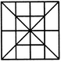
- 13
- 16
- 19
- 20
Q2) How many rectangles are there in the figure below?
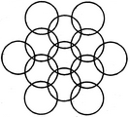
- 8
- 17
- 18
- 20
Q3) In the figure given below, if the centers of all the circles are joined by horizontal and vertical lines, then find the number of squares that can be formed.
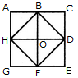
- 6
- 7
- 8
- 1
Q4) How many triangles & parallelograms are there in the following figure?
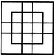
- 21, 17
- 19, 13
- 21, 15
- 19, 17
Q5) What is the minimum number of straight lines required to construct the figure given below?
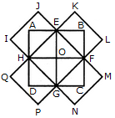
- 11
- 13
- 15
- 21
Q6. What is the number of straight lines in the following figure?
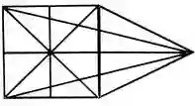
A) 10
B) 12
C) 13
D) 17
Q7. How many Triangles are there in a given figure?
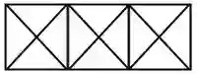
A) 28
B) 24
C) 25
D) 26
Q8. How many Triangles are there in the following figure?
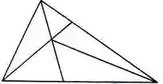
A) 6
B) 10
C) 11
D) 12
Q9. Find the number of triangles in the figure?
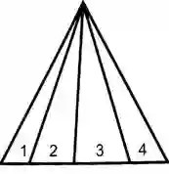
A) 6
B) 10
C) 11
D) 16
Q10. Find the number of triangles in the figure?
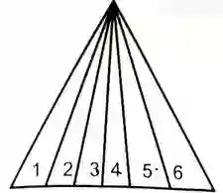
A) 20
B) 24
C) 21
D) 23
Q11. Find the number of triangles in the figure?
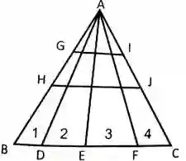
A) 20
B) 24
C) 21
D) 23
Q12. Find the number of triangles in the figure?
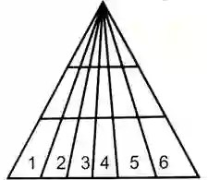
A) 60
B) 64
C) 61
D) 63
Q13. Find the number of triangles in the figure?
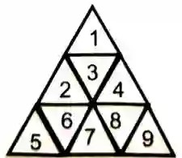
A) 20
B) 18
C) 13
D) 22
Q14. Count the number of triangles in the figure?
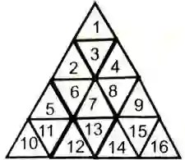
A) 27
B) 23
C) 16
D) 23
Q15. How many rectangles are there in the figure given below?
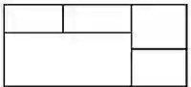
A) 6
B) 7
C) 8
D) 9
Q16. How many bricks are there in the following figure?
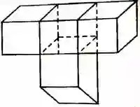
A) 2
B) 4
C) 6
D) 8
Q17. How many parallelograms are there in the following figure?
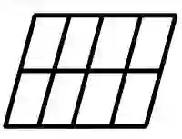
A) 20
B) 24
C) 28
D) 30
Q18. What is the number of rectangles in the following figure?
A) 6
B) 7
C) 9
D) 11
Answers
- B
- C
- C
- A
- B
- B
- A
- D
- B
- C
- C
- D
- C
- A
- D
- B
- D
- C

